**5 self-hosted tools you can supercharge with a local LLM**

Story by Sumukh Rao

After a successful run with self-hosting several apps and services over the past few months, I recently decided to delve deeper into the rabbit hole by hosting an LLM on my home server. Thankfully, [self-hosting LLMs is simpler than I thought](https://www.xda-developers.com/i-started-self-hosting-llms-absolutely-loved-it/?utm_source=syndication&pubDate=20250808). I recently started learning to code, so integrating [Ollama with VS Code also allowed me to self-host an LLM that could help me write code](https://www.xda-developers.com/this-free-vs-code-extension-uses-locally-hosted-llm-to-help-code/?utm_source=syndication&pubDate=20250808" \t "_blank). Since I enjoyed the process, I considered other ways to effectively utilize local LLMs. That's when I figured that a bunch of my self-hosted apps could benefit from the added AI advantage.

So, I naturally integrated a few of them with a local LLM. Once done, I unlocked the full potential of several apps and software that I wasn't aware of earlier. Something as simple as a [note-taking app](https://www.xda-developers.com/this-self-hosted-markdown-editor-is-my-new-favorite-way-to-take-notes/?utm_source=syndication&pubDate=20250808) was suddenly more helpful, and my local storage and file-sharing solution, [Nextcloud,](https://www.xda-developers.com/uninstalled-onedrive-and-replaced-it-with-this-free-tool-instead/?utm_source=syndication&pubDate=20250808" \t "_blank) is more useful than ever. The best part is that you can integrate LLMs with some of the most popular self-hosted apps, and all of this can be done for free. Among all the apps I tried linking with LLMs, here are some with the best results.

**n8n**

**Better automations with AI**

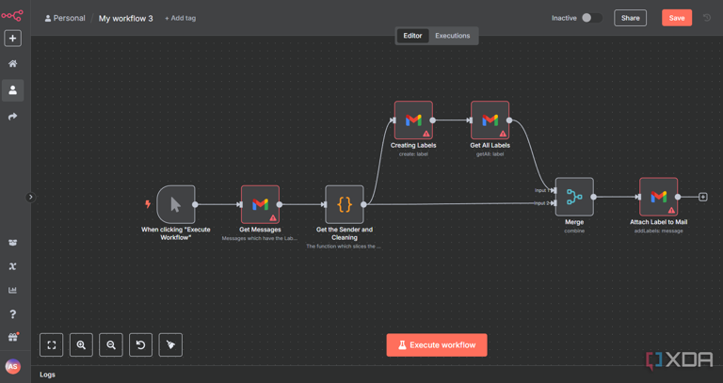

n8n workflow

For those unaware, n8n is an extremely powerful automation tool where you can create multiple scenarios with different outcomes. You can use it to create [automations for your home lab](https://www.xda-developers.com/must-have-n8n-automations-for-your-home-lab/?utm_source=syndication&pubDate=20250808), generate an automatic expense monitor, manage customer support tickets, or even automate your social media feeds. While all of this can be done natively, creating the automation pipeline can be challenging. Integrating an LLM with n8n solved this issue for me.

n8n has a built-in Ollama node and a custom HTTP request node that you can take advantage of. You can then use AI-powered automation, like reading a user's input and carrying out relevant action, extracting data from an input, or generating automatic responses for a chatbot. These automations can be used for customer support, summarizing input, or even extracting insights from a dataset.

**Nextcloud**

**Search for your files easily**

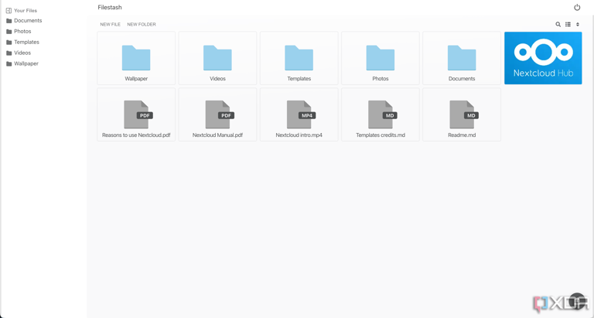

Filestash nextcloud storage

Ever since I gave up on cloud storage, I have been using Nextcloud to store my files. In fact, it's also become my collaborative [productivity suite of choice](https://www.xda-developers.com/nextcloud-beats-microsoft-365-entirely-for-free/?utm_source=syndication&pubDate=20250808) after I stopped using Google Docs. Well, I improved its functionality further by pairing it with LocalAI. It's essentially an OpenAI-compatible API bridge to local LLMs.

If you're wondering what you can achieve with it, well, I use it mainly for document summarization. Whenever I upload large documents with multiple pages, I can use the LLM to generate a quick one-page summary. This is helpful for contracts, reviewers' guides, and NDAs that I view on a regular basis.

**Home Assistant**

**Use AI for automations**

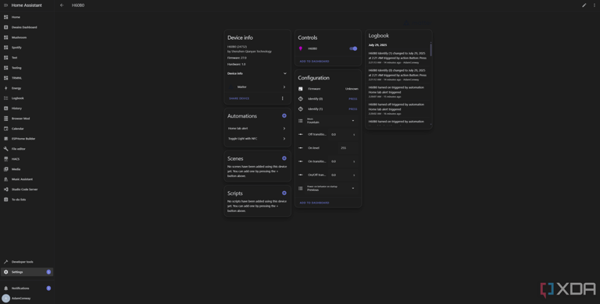

govee-lamp-matter-server-home-assistant

The biggest issue that I had with my IOT devices was solved by Home Assistant. [I replaced all the proprietary apps and software with Home Assistant](https://www.xda-developers.com/replaced-all-smart-home-apps-with-home-assistant/?utm_source=syndication&pubDate=20250808), and my smart home was finally truly smart. Apart from making things a lot more convenient, though, integrating Ollama with Home Assistant is a great way to extract better functionality from the service.

You can use your voice commands to perform actions, generate automation scripts without any manual work, and even ask AI to give you summaries of your device usage — which lights are turned on for longer durations, what's the average temperature on the thermostat, etc. It's a good way to get an insight into your smart home usage.

**Joplin**

**Pen down notes with the help of AI**

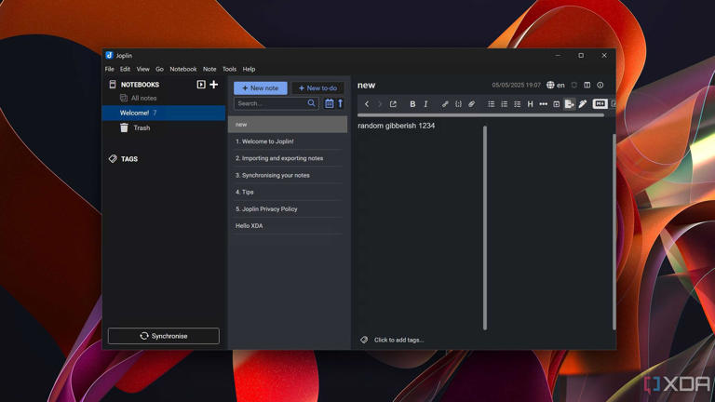

Running Joplin inside Windows 11

After using Google Keep for years, I recently migrated all my notes to Joplin. It's one of the best self-hosted note-taking apps out there with a simple interface that just works. I also use it as my to-do list to improve my daily productivity. Just like other services, I use Ollama with Joplin to give my notes a touch of AI. Here's everything I use it for.

Summarize the notes I take during meetings and briefings, because they're generally quite a lot. This saves me time regularly. AI can also determine what a note is related to and automatically categorize it for me. The best feature, though, is how I can use natural language to search within every note. I would highly recommend this if you're a student.

**Seafile**

**Tagging is easier than ever**

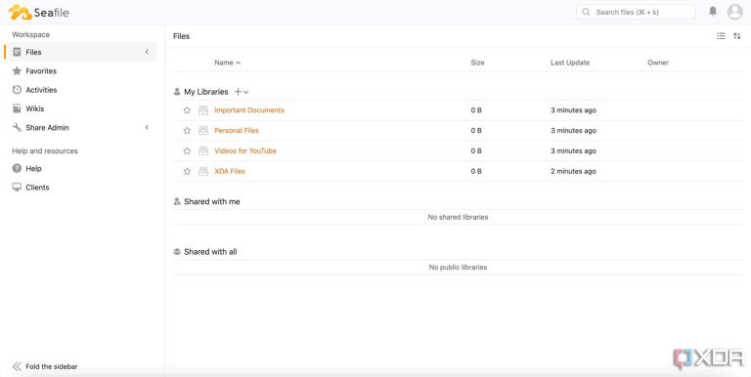

Seafile homepage

Recently, I set out to find an alternative to Nextcloud, especially because the platform had started to feel slow when trying to upload or download large sets of files. That's when I encountered Seafile. Apart from being more nimble compared to Nextcloud, Seafile is also much cleaner in terms of looks and features. But you can always supercharge it by linking it to an LLM.

In this case, I used Ollama to improve the search functionality inside Seafile to help me find specific documents. For example, I don't remember the names of all the documents I upload. However, searching for keywords pertinent to the contents of the document is good enough when using an LLM.

**Add a touch of AI to your apps**

While all the self-hosted services I use are pretty handy by themselves, adding a layer of intelligence to them makes them a lot easier to use. For instance, I don't have to manually add [integrations in n8n](https://www.xda-developers.com/using-n8n-automate-workflow/?utm_source=syndication&pubDate=20250808) that can read user input or extract data from a text string — an LLM can do that for me. Similarly, automatically identifying the type of file I upload to Nextcloud and placing it in the relevant folder saves a significant amount of time and effort — especially if I repeat the process multiple times a day. After all, AI is here to make our jobs easier, and this is an excellent way to use it.